**Name: Anandi Deshkar**

**Division: CS4**

**Batch: C42**

**Roll.no: 32**

**PRN: 202401040212**

**ACTIVITY 1: IMDB dataset**

1. **Find the number of unique movies.**

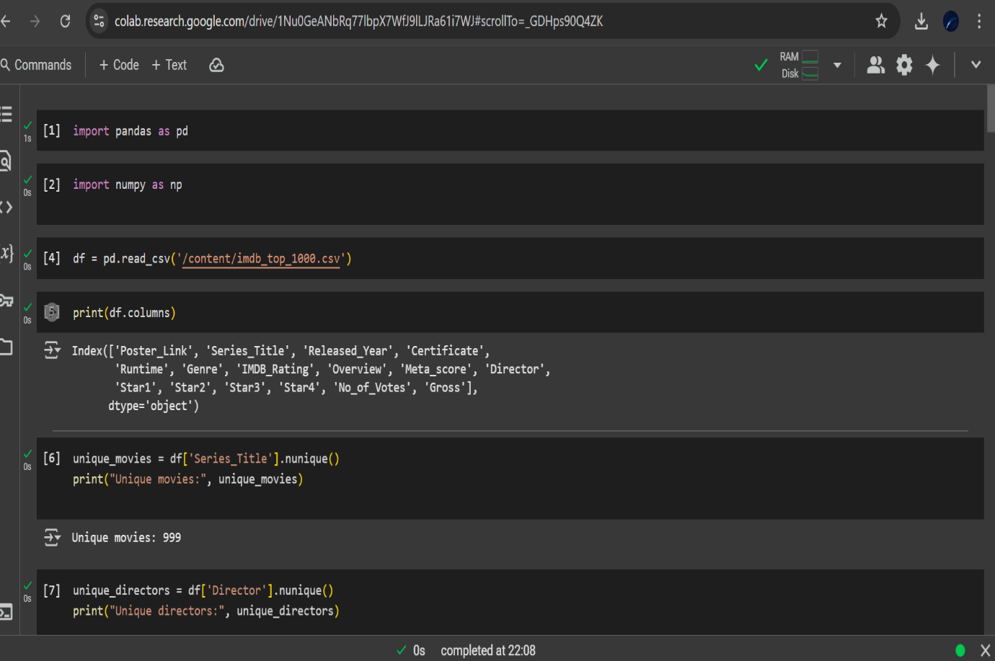

1. **Find the number of unique directors.**
2. **Find the oldest movie in the dataset.**

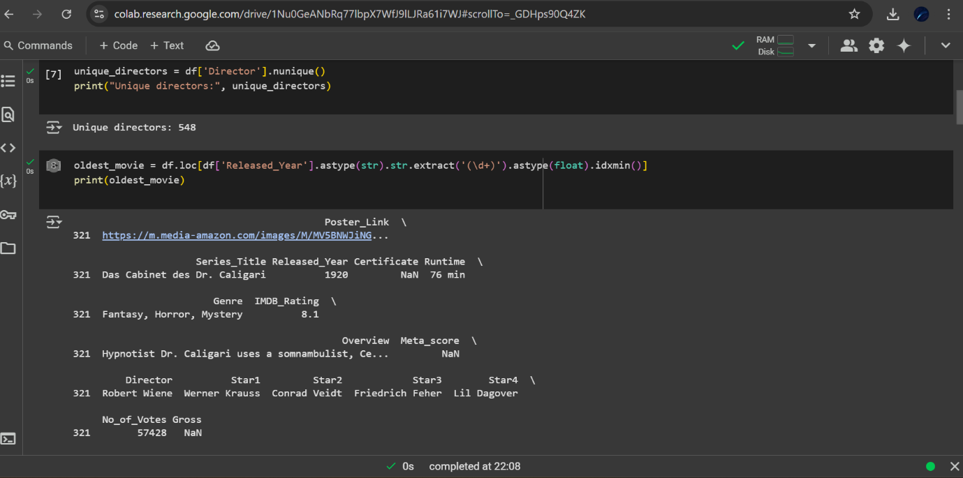

1. **Find the newest movie in the dataset.**
2. **Find movies with IMDB rating greater than 9.**

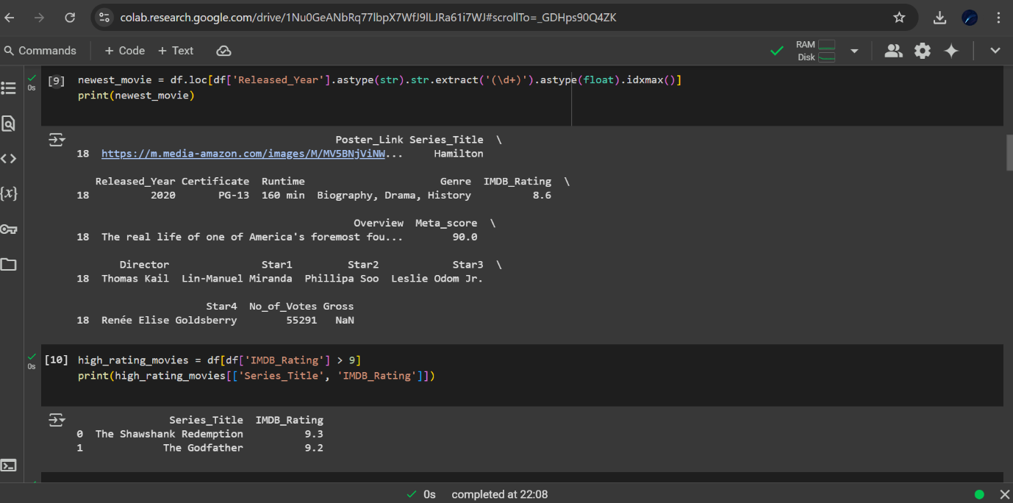

1. **Find the top 10 highest grossing movies.**
2. **Find the movie with the longest runtime.**

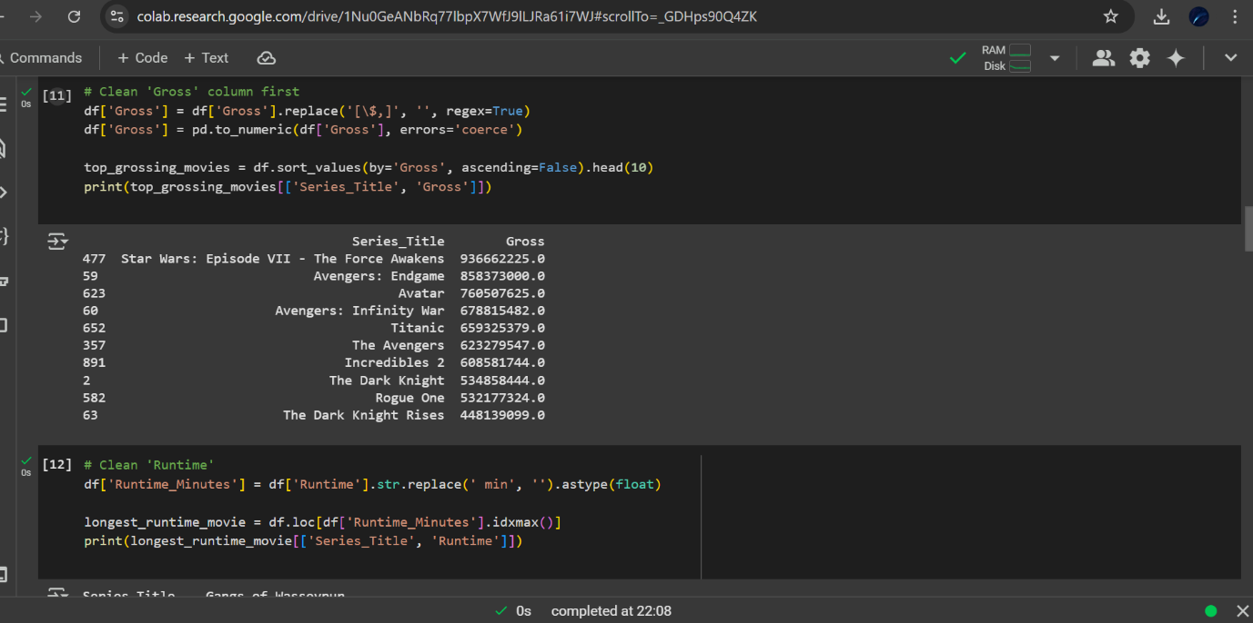

1. **Find the movie with the shortest runtime.**
2. **Find the top 5 directors with the most movies in the list.**

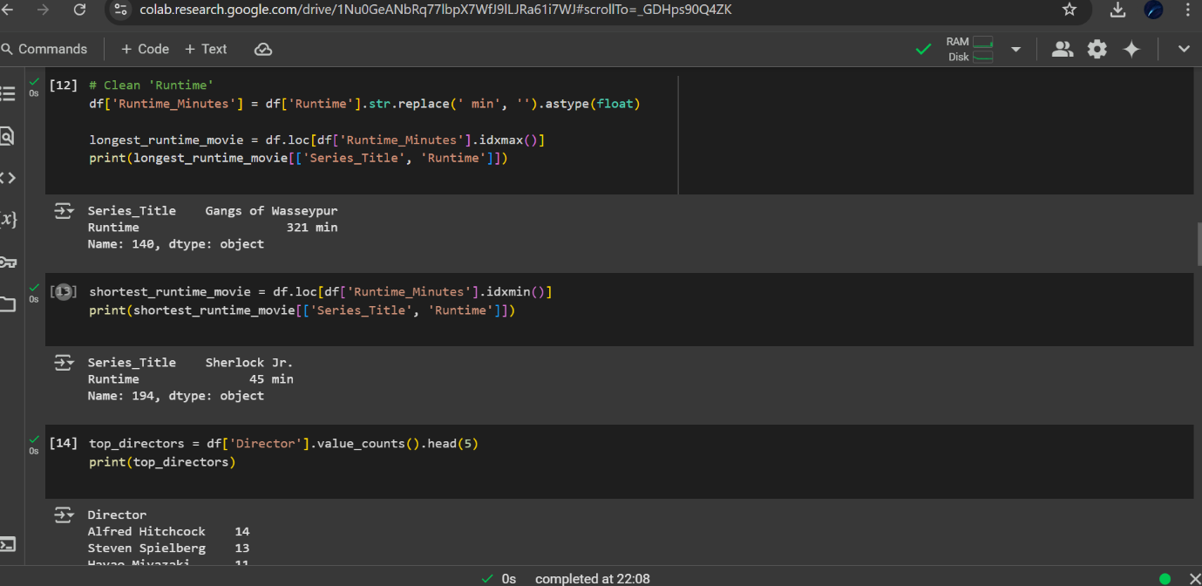

1. **Find the number of movies for each certificate type.**

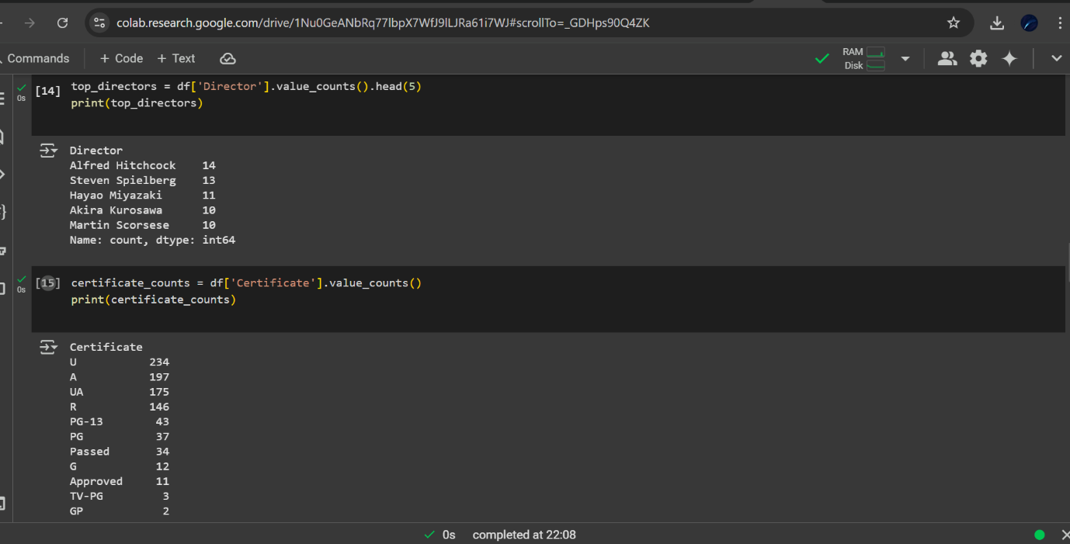

1. **Find the average IMDB rating per director.**
2. **Find movies with no Meta score.**

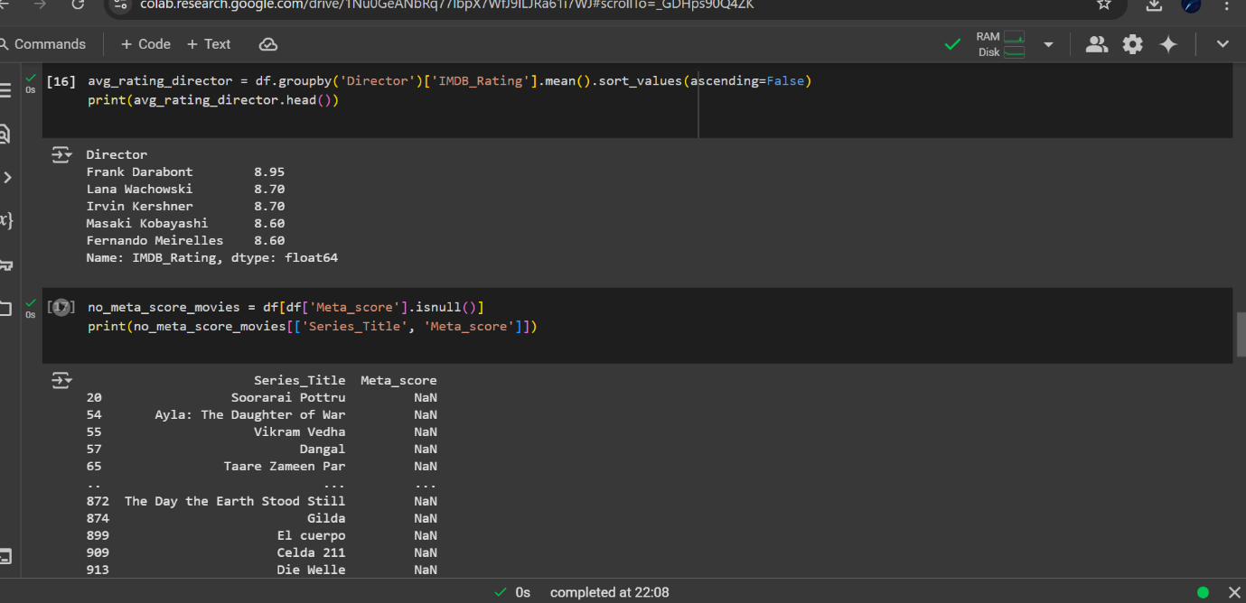

1. **Find movies belonging to multiple genres.**

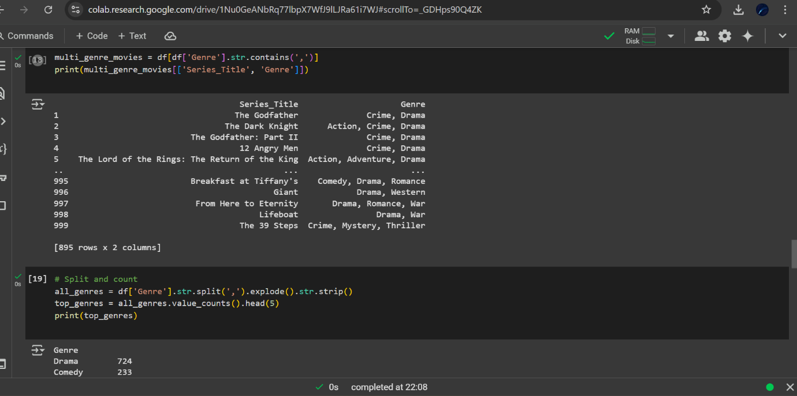

1. **Find the top 5 most common genres.**
2. **Find the total gross earnings of all movies combined.**
3. **Find the actor who appears most frequently across all movies.**
4. **Find how many movies have a Meta score above 90.**
5. **Find the average runtime of all movies.**
6. **Find the movie with the highest number of votes.**
7. **Find movies where all four main stars are unique across the dataset (no repeated star actors).**

